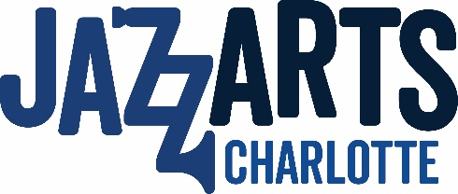
Social Media & Marketing Intern

Summer 2021

Description
Do you enjoy jazz and wish to expand your experience in marketing? JazzArts Charlotte is searching for an intern that will play an integral part in developing our message and engage our audiences across the digital media landscape and various social platforms.
The successful candidate will get the opportunity to attend, record and promote all JazzArts Charlotte events through social media. They will also be responsible for additional content creation, maintaining social media accounts, monitoring and engaging in online forums, participating in outreach and promotion, and conducting analysis.
This position is a learning opportunity for a college student to engage in hands-on experience focused in Social Media Marketing. The qualified intern will need strong critical thinking skills and will be expected to manage a variety of defined tasks, and complete deliverables on-time as requested.
This is a great opportunity for someone who enjoys variety in the day-to-day routine and is looking to gain experience in a fast-paced environment. An un-paid internship (for University credit) with JazzArts Charlotte is designed to provide you with quality, real world experience through participating in all avenues of digital media marketing.
To apply, please send resume, writing samples, and a list of social media accounts to Rebecka Nelli at info@TheJazzArts.org.
Responsibilities
- Work with Marketing Director to create and implement campaigns.
- Develop compelling content ideas to further engage and excite audiences.
- Plan content calendars on a weekly and monthly basis.
- Schedule social media posts daily across all platforms.
- Monitor analytics to track progress toward goals and identify new opportunities.
- Take photos and videos during events for use in social media and other communications.
- As a team player, all marketing team members support a variety of other marketing related tasks as needed.

Qualifications & Skills
- College level courses in marketing, communications or related discipline. Major in Marketing or Business Administration preferred.
- In-depth working knowledge of Facebook, Twitter, Instagram, LinkedIn and/or YouTube.
- Experience with social media analytics a plus.
- Excellent communication skills.
- Solid creative writing skills.
- Excellent organizational skills.
- Ability to balance, multi-task and prioritize requests and still meet deadlines.
- Proficient in Microsoft Applications. Basic knowledge of Photoshop, Canva, or InDesign.
- Available to work 10-15 hours a week.

